VEGAS Pro 19
Introduction to the new features: Initial release and update 1 (build 381)
Adjustment Tracks
Adjustment tracks provide a way to apply video effects to multiple tracks simultaneously. To add an adjustment track, choose Insert | Adjustment Track. Now any effects you apply to that track at the track level will also affect all tracks beneath it in your project track list.
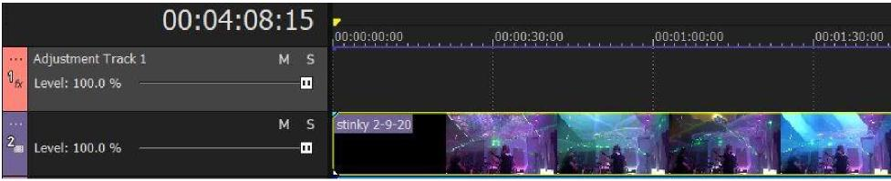
To see how this adjustment track works in your project, add several video clips to your project, all on different tracks beneath your adjustment track. Add a video file to at least one track above your adjustment track. Stagger all of the video events so that they do not overlap.
Now, click the Track FX button in the adjustment track’s track header. From the Plug-In Chooser, add an easily noticeable video effect such as a Lens Flare. Click in your timeline so that your project cursor sits within one of the events in a track below the adjustment track.
In the Video Track FX window, make adjustments to the Lens Flare so that you can see it clearly. Notice that the effect that you applied at the track level of the adjustment track affects the video in the event on the track below it. Click through your timeline to test all of the other events in your project. Notice that the Lens Flare shows on every event that sits on a track below the adjustment track, but not on the event that sits on a track above the adjustment track.
With your cursor sitting within one of the events below the adjustment track, lower the adjustment track’s Level slider. Notice that this controls the strength of the effect on all of the tracks influenced by the adjustment track. Set the Level slider back to 100.0%.
Next, notice that the adjustment track has a blue line running through the top of it. This is the track’s Composite envelope. You can use this envelope to change the adjustment track’s composite level over time. Double-click the envelope to add a point and then change the value of that point. Add more points throughout your project to see how you can raise and lower the strength of the effect over time. This gives you great flexibility to include an event on a track that would normally be influenced by the adjustment track but set it so the event is not influenced.
You can also use the compositing parent/child relationship between tracks to control which tracks become influenced by the adjustment track. To see this, click the More button for the track directly below the adjustment track. From the menu, select Make Compositing Child. Make the next track down a compositing child of the adjustment track as well.

Now, click around your project. Notice that the tracks that you’ve marked as child tracks of the adjustment track remain under the influence of the adjustment track. But any tracks that are not children of the adjustment tracks--even though they are below the adjustment track--are no longer influenced by it. This gives you great flexibility to choose just the tracks you want associated with the adjustment track.
Finally, you can add as many adjustment tracks to your project as you need. So, say track 1 is an adjustment track. It will influence tracks 2 through 5 (assume no parent/child relationships exist). Now, say track 3 is also an adjustment track. That track will influence tracks 4 and 5, but not track 2 which is above it in the track order. In this case, tracks 4 and 5 are influenced by two different adjustment tracks.
Sometimes you might want to change the video effect on the tracks affected by your adjustment tracks over time. For instance, say you have a three-minute video. During each individual minute you want a different video effect to influence all the tracks below the adjustment track. You have a couple of different approaches to accomplish this.
First, you could add a new adjustment track for each individual minute (in our example above). So, add three adjustment tracks and add one of the three different effects to each of the tracks. Now use your Composite envelopes on these adjustment tracks to “cut” the effect in and out at the appropriate time on each adjustment track. So, at any one time, the effect of only one track passes through to the tracks you want to influence.
To keep your project organized if you use several adjustment tracks in this manner, select each of the adjustment tracks. Right-click one of the selected tracks and choose Track Group | Group Selected Tracks from the context menu. Now click the Collapse Track Group button so that you have just one small track group visible and you can reclaim the timeline space taken by the adjustment tracks.
You can also accomplish the task with just one Adjustment track. To use this method, add the three video effects to the Adjustment track’s Video FX chain. Now find a parameter in each of the video FX that controls the strength of the effect. Click the Animate button for that parameter. Now use the animation timeline and keyframes to turn that effect off when you don’t need it and on when you do. Do this for each of the effects. In this way you can add multiple effects to one adjustment track and control when the effect actually influences the tracks below and when it does not.
You can get quite sophisticated with your tracks and effects by combining all of these features in this way.
VEGAS Pro 19 Introduction to the new features: Initial release and update 1 (build 381)
2

Apple ProRes
Note: This feature is still in beta.
Apple ProRes is an industry standard intermediate codec that does its best to preserve detail in your footage across multiple generations of edits. VEGAS Pro supports both import and export for Apple ProRes files.
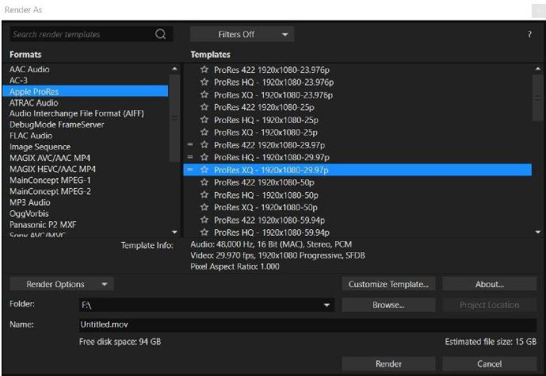
To Render to Apple ProRes, choose File | Render As. In the Render As dialog box, select Apple ProRes from the Formats list. Select a render preset from the Templates list. Templates whose properties match those of your project contain an Equal sign (=) to the left of their
names. To create a custom template, select the template that most closely matches the one you want to create and click the Customize Template button.
In the Custom Settings - Apple ProRes dialog box, set the parameters that you want.

VEGAS Pro 19 Introduction to the new features: Initial release and update 1 (build 381)
3

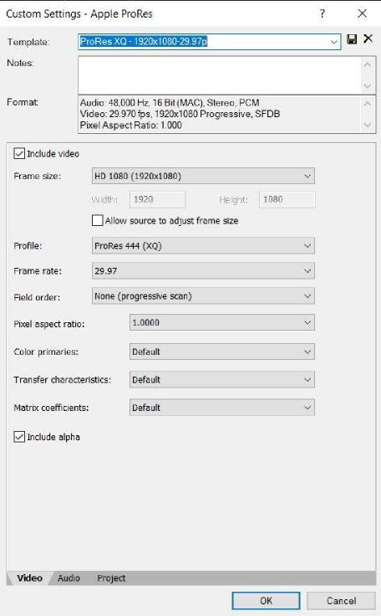
Enter a name for your custom template into the Template field and click the Save Template button. Enter any notes you want in the Notes field.
Specify your desired values in the remaining fields:
- Frame Size: The resolution you want to render to. Apple ProRes supports custom resolutions as well as standardized resolutions
- Profile: The ProRes encode mode being used:
- ProRes 422 (Proxy): the most highly compressed ProRes encoding option, intended for proxy usage with a data rate of approximately 45mbps for 1080p video at 29.97fps
- ProRes 422 (LT): a compressed form of ProRes 422, but better quality than the proxy version with a data rate of approximately 102mbps for 1080p video at 29.97fps
- ProRes 422: uses 4:2:2 YUV compression with a data rate of approximately 147mbps for 1080p at 29.97fps
- ProRes 422 (HQ): uses 4:2:2 YUV compression, but it has a much higher data rate of approximately 220mbps for 1080p at 29.97fps
VEGAS Pro 19 Introduction to the new features: Initial release and update 1 (build 381)
4

- ProRes 4444: uses 4:4:4 YUV compression and supports 12-bit color and 16 bits for the alpha channel with a data rate of approximately 330mbps for 1080p 30fps
- ProRes 4444 (XQ) utilizes 4:4:4 YUV compression and supports 12-bit color and 16 bits for the alpha channel with a data rate of approximately 500mbps for 1080p 30fps
- Frame Rate: The number of frames per second that your rendered file uses
- Field Order: If shooting interlaced footage that you do not want to render de-interlaced, you can specify the field order to render here. Remember to also set your project settings to the same field order
- Pixel Aspect Ratio: A ratio that defines the width of the rendered pixels. For most HD and 4K formats, 1.0 is the proper aspect ratio
Click the Audio and Project tabs in turn to specify any changes you want to make on those tabs. When you’re done with your customizations, click the OK button.
Specify a save location in the Folder field, give your new file a name, and click the Render button.

VEGAS Pro 19 Introduction to the new features: Initial release and update 1 (build 381)
5

Custom Reference for Style Transfer
In the Style Transfer video effect plug-in, the Custom Reference style source option enables you to use any image as the style source that you want to transfer to your video image. As with all AI plugins in VEGAS Pro, you must install the VEGAS Deep Learning Models package on your system for this effect to work. If you need to install the VEGAS Deep Learning Models, download the installer.
To use a custom reference for your footage, add the Style Transfer effect to an event in your timeline.
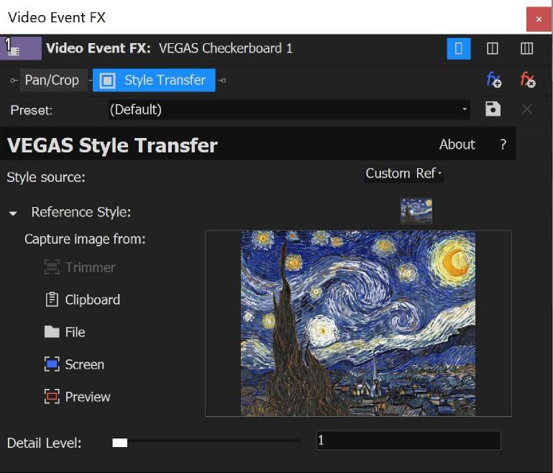
In the Video Event FX window, choose Custom Reference from the Style Source drop-down list. Click the item from the Reference Style options list that corresponds to the source you want to capture the reference image from. Here is a list of the options and how each of them works:
- Trimmer: Load a file into your Trimmer window, then select this option to apply the characteristics of that file to your footage
- Clipboard: Copy information to your Windows clipboard, then select this option to apply the characteristics of the clipboard information to your footage
- File: Click this button and navigate to an image file stored on your computer drives to apply the characteristics of that file to your footage
VEGAS Pro 19 Introduction to the new features: Initial release and update 1 (build 381)
6

- Screen: Click this button, then drag the selection rectangle around any area of your computer screen (including the entire screen) to apply the characteristics of that area to your footage
- Preview: Place your timeline cursor within an event on your timeline so that it shows in the Video Preview window and then click this button to apply the characteristics of that image to your footage
Once you’ve specified your reference source, adjust the Detail Level slider to dial in the exact effect you want. Higher values give more detailed results at the expense of longer processing time.

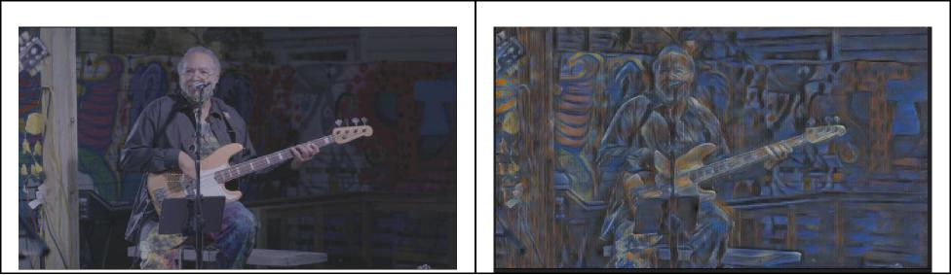
Before
After

VEGAS Pro 19 Introduction to the new features: Initial release and update 1 (build 381)
7

BlackMagic RAW

Note: This feature is still in beta. Some features may not work as expected.
BlackMagic RAW is lossless video codec that offers the benefits of RAW recording, such as the ability to set ISO and white balance after shooting. It also offers lower bitrates and fast CPU and GPU decoding.
VEGAS Pro 19 supports Blackmagic RAW files. You can add these clips to your timeline just as you would any other file. Once you have them on your timeline, you can use all of the normal editing tools to work with them.
In order to adjust the RAW settings for the clip, right-click the clip in the Project Media window, and select File Format Properties from the context menu. These controls enable you to adjust various RAW settings, such as color temperature or ISO.
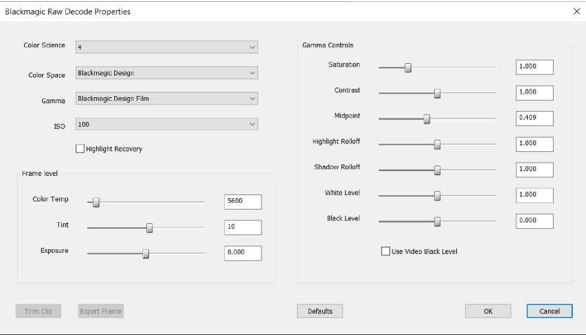
Note that in the initial implementation, to adjust the Gamma Controls settings, first select BlackMagic Design Custom from the Color Space drop-down list.
If you’ve made adjustments to these controls and want to reset them to their default settings,
click the Defaults button.
VEGAS Pro 19 Introduction to the new features: Initial release and update 1 (build 381)
8

When you’re done with your adjustments, click the OK button.
Another important note: the process of working with raw files and adjusting the format settings can create several companion files, some of which are generated only after you add the file to your timeline. You'll find these files in the same folder that you stored your original raw file in and they’ll have the same name as the video file, but with different extensions. If you move your raw file to a new file system location, make sure to move all of the companion files along with it. If you don’t, returning to the camera defaults may have unpredictable results, your proxy files may not function properly, and other issues may arise.

VEGAS Pro 19 Introduction to the new features: Initial release and update 1 (build 381)
9

Camera and Look LUT Presets
VEGAS Pro contains a collection of Input Lookup tables (LUTs) that convert color spaces (such as VLOG/VGamut, SLOG, or CLOG) used in many popular cameras to Rec709, the color space used for most video editing projects. These LUTs—called camera LUTs or input LUTs—are useful for projects that use an 8-bit pixel format (the majority of projects for most users). For users who work with 32-bit full-range projects, the Color Space settings in the media properties for your clips provide similar functionality.
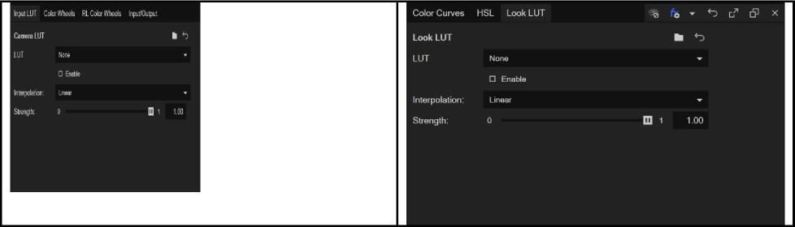
VEGAS Pro also contains a selection of Look LUTs that color grade your image to emulate the look of a number of popular films, music videos, and TV shows.
To set an input or look LUT, click the Color Grading button to open the color grading panel. To specify an input LUT, click the Input LUT tab. Click the LUT drop-down list and select a LUT preset from the menu.
To apply a look LUT, click the Look LUT tab. Click the LUT drop-down list and select a preset from the menu.
Once you have an input or look LUT selected, click the Interpolation drop-down list and choose an option from the list. Choose Linear for fast and reasonably accurate results. Choose Tetrahedral for more accurate, but slightly slower results.
The LUT filter produces a blend of the original image and the color-adjusted image. Adjust the Strength slider to control the mix, or the percentage of the color-adjusted image vs. the original image. A setting of 0 shows the same results as if you do not apply any LUT at all.
VEGAS Pro 19 Introduction to the new features: Initial release and update 1 (build 381)
10

Color Curves Split Mode
The color curves in VEGAS Pro give you a powerful tool for fine-tune adjustments to your video’s brightness, contrast, and color. The VEGAS Pro Color Grading panel features four curves, one for brightness, and one for each of the three primary colors, red, green, and blue.
To access the Color Curves, click the Color Grading button to open the Color Grading panel. Click the Color Curves tab to make that the active section. In the default configuration, all four color curves use a single graph, but only the Brightness curve appears to begin with.
To adjust your video’s shadows, drag the control on the left end of the Brightness curve. To adjust the highlights, drag the control on the right end. Use the yellow curve handles that appear on each control point to change the shape of the curve without moving the point. Each of the other curves works the same way.
You can also add additional control points to any curve for even greater control. To add a new control point, double-click the curve line at the location you want the new point.
Notice that control points that are not endpoints have two handles you can use to change the shape of the curve. When you move one of the handles, the point’s other handle also reacts to the movement. If you want to move one handle without changing the shape of the curve on the other side of the control point, right-click the control point and choose Lock Tangents from the context menu. With Lock Tangents disabled, you can change one handle without also changing the other.
To activate the other curves, click the Select Curves button and select the checkbox for the curve you want. All of the curves you activate will appear on this same graph.
Since working on multiple curves over one graph can be a bit confusing, you can also view all four curves simultaneously. To do this, drag the left border of the Color Curves section to the left. After you expand the panel far enough, the four color curves appear side by side each on its own graph, as seen in the image below.
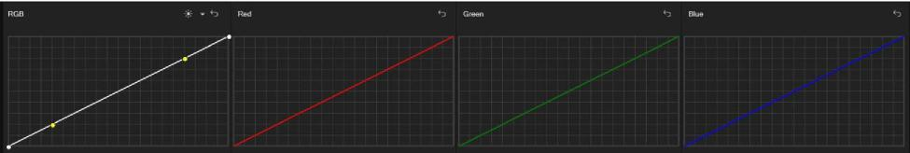
VEGAS Pro 19 Introduction to the new features: Initial release and update 1 (build 381)
11

Colorization
Colorizing black and white footage has never been easier thanks to the AI-powered Colorization effect in VEGAS Pro. Add this effect to the Media FX or Video Event FX of any timeline clip event, and you’ll instantly bring color to your footage.
You can then adjust the various controls available in the Colorization FX window to further refine the results.
Like the other AI-powered effects in VEGAS Pro, in order for the Colorize effect to work properly, you must first install the VEGAS Deep Learning Models. Follow the link that you received with your VEGAS Pro purchase to download the Deep Learning Models installer. You can also download the installer with this link.
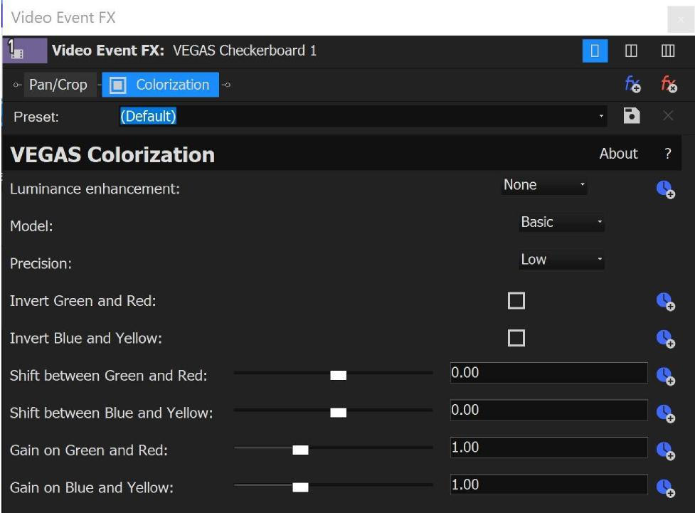
To colorize your footage, click the Video FX tab to make the Video FX window visible. Select the Colorization filter from the list of plug-ins. Drag the preset that you want onto your timeline clip event.
VEGAS Pro 19 Introduction to the new features: Initial release and update 1 (build 381)
12

In the Video Event FX window, the Luminance Enhancement setting adjusts the brightness and contrast of your footage. Choose Estimation only (do not apply to output) from the drop-down list if you just want a preview of what this enhancement would look like. Choose Apply to output if you intend to render the enhancement into your final project.
The Model drop-down list enables you to select which AI model the filter uses to apply color to your footage. Basic works well in many cases that involve landscapes and wide scenes. For more difficult footage--especially where human skin tones appear--the Enhanced model often produces superior results.
Precision determines how much detail the tool uses to analyze your footage when adding color to the image. Be sure to try all the possible modes, as in some cases, the lower precision modes can produce superior results to the higher precision modes, and they render faster as well.
Use the Invert, Shift, and Gain controls to fine-tune your color even further.
Several of these controls support animation so you can change their values over time. To animate any of these settings, click the Animate button that corresponds to the setting.

VEGAS Pro 19 Introduction to the new features: Initial release and update 1 (build 381)
13

Import Mocha Tracking Data
To import the motion tracking data from Mocha into VEGAS Pro, first export the data from Mocha in the Silhouette Corner Pin format, if you’re exporting tracking data, and the Mocha shape for AE format if you’re exporting shape data.
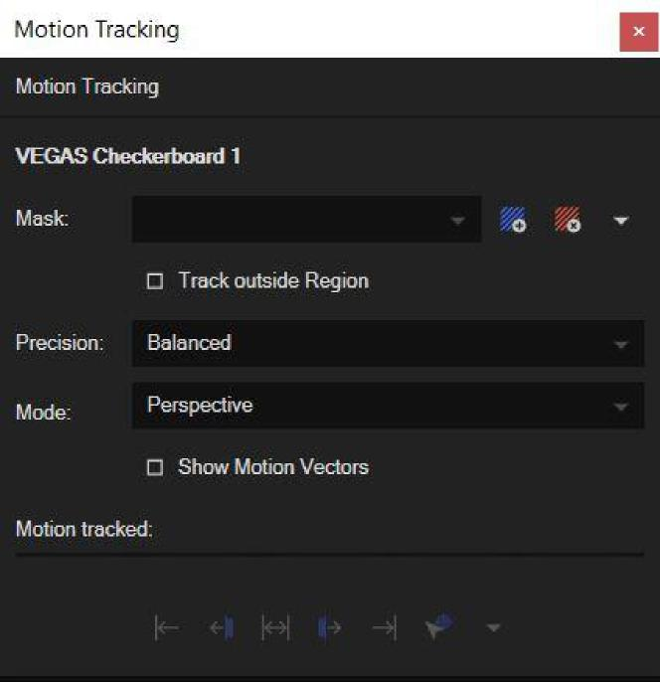
In VEGAS Pro, click the More button on the event to which you want to apply motion tracking. Choose Motion Tracking from the menu.
In the Motion Tracking window, click the Mask drop-down arrow and choose Import from Mocha from the list. Navigate to the location where you saved the Mocha tracking data you exported, select that file, and click Open.
The Mocha tracking data is now imported into the VEGAS Pro motion tracker and you can use it just as if you had generated that data inside VEGAS Pro.
VEGAS Pro 19 Introduction to the new features: Initial release and update 1 (build 381)
14

Optical Flow Slow Motion
In order to create slow motion, VEGAS Pro delays the original frames of the video so that there is more time between the movement those frames record. To attempt to create continuous motion, VEGAS Pro must create additional video frames to fill in the extra time between the original frames.
When you use the Playback Rate setting or the Velocity Curves to create slow motion, VEGAS Pro creates exact copies of the existing frames to use as these extra frames. Since the original frames are repeated, the process can result in choppy slow-motion sequences.
The Slow Motion Plug-In, on the other hand, synthesizes new intermediate frames from the existing frames. To do this, it analyses and interprets the differences between two frames to create entirely new frames that move smoothly from the first frame to the second. This makes the slow motion look much more fluid and natural in many cases.
For this process, VEGAS Pro leverages real-time computation technology that requires no prior analysis.
To apply the Slow Motion plug-in to your footage, click the Video FX tab to open the Video FX window. Select Slow Motion from the list of plug-ins. Drag the Default preset onto the timeline clip event that you want to apply it to.

VEGAS Pro 19 Introduction to the new features: Initial release and update 1 (build 381)
15

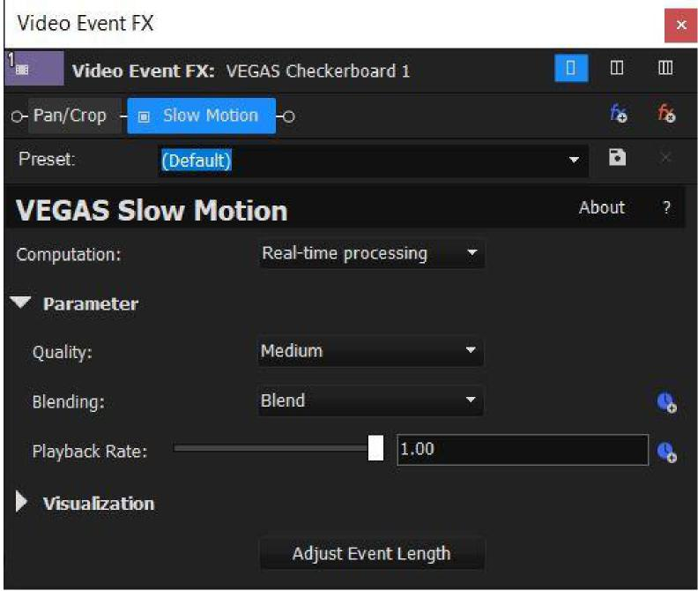
In the Video Event FX dialog box, notice that the Computation drop-down list contains a Preprocessing option. This option exists solely to support legacy projects that have used it. In no case should this option provide superior quality, so unless you’re working with an old project that used it already, use the Real-time option for your projects. In fact, select Real-time processing from the list and see if you are happier with the results.
Click the Quality drop-down list and choose the setting you want. This setting determines the analysis precision in terms of how much video information the tool considers during the process. Experiment with these options. You might find that the lower-quality settings give adequate results with lower processing requirements.
Experiment with the Blending options to see which of those you like best.
Adjust the Playback Rate to set the new speed you want your video to play back at.
If you’re an expert user, you might find it helpful to view the optical flow field information. To view this, click the Visualization drop-down arrow and select the Show Optical Flow Field checkbox.
VEGAS Pro 19 Introduction to the new features: Initial release and update 1 (build 381)
16

Once you’ve applied slow motion, your timeline event will no longer be long enough to hold all of the footage it did before you slowed the footage down. For example, if you slow your footage down to a rate of .5, only half of the original frames fit into the event. To automatically adjust the length of the event so that it once again holds all of the original frames, click the Adjust Event Length button. This stretches your event to the size necessary to play the full media with the Slow Motion effect applied.

VEGAS Pro 19 Introduction to the new features: Initial release and update 1 (build 381)
17

Project Notes
Project Notes allow VEGAS Pro editors to leave themselves notes in a project or to collaborate on a project and leave notes for each other along the way. Each note has a specific timeline timecode, so you can use them to leave comments in exact points in your project. You, can categorize them by colors and custom labels, and the system can keep track of which notes have been addressed and which still need attention.
To use Project Notes, click the Project Notes tab if necessary to make the window visible.
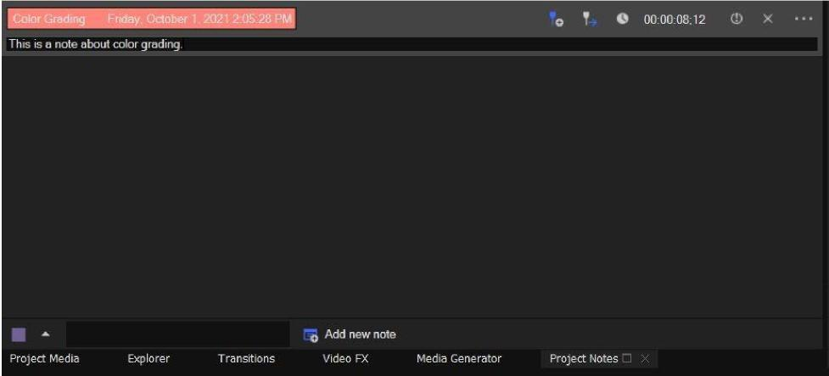
Click the Note Default Color button and choose the color from the list that you would like all of your new notes to take on. Click inside the Enter default label text field and type any label you would like all new notes to take on. Click the Add New Note button to create a note with these default settings. This note contains the timecode that corresponds to your current cursor location in the timeline.
To change the timecode, click in the timeline to place your cursor at the new location and click the Update Timecode to Timeline Cursor button.
To instantly move your timeline cursor to the location of any note, click the note’s Jump to Timecode button.
To manually edit a note’s timecode, select the note’s current timecode value and type the new timecode into the text box, then press the Enter key.
Click the Resolve Note button to indicate that you have addressed the issue mentioned in the note. Click the button again (notice its name has changed to Unresolve Note) to return the note to an unresolved state.
VEGAS Pro 19 Introduction to the new features: Initial release and update 1 (build 381)
18

Select the Hide resolved notes checkbox to limit your note view to just the unresolved notes in your list. Deselect the checkbox to show all notes whether resolved or not.
Click the Delete Note button to delete a note from the Project Notes window.
Click a note’s More button. In the menu you can select a new color for this note from the list or select the note’s current label so you can type a new label.

VEGAS Pro 19 Introduction to the new features: Initial release and update 1 (build 381)
19

Range-Limited Color Wheels
The Range-Limited Color Wheels enable you to define a specific range of colors that adjustments to the various color wheels affect. To access the Range-Limited Color Wheels, click the RL Color Wheels tab in the VEGAS Pro Color Grading Panel.
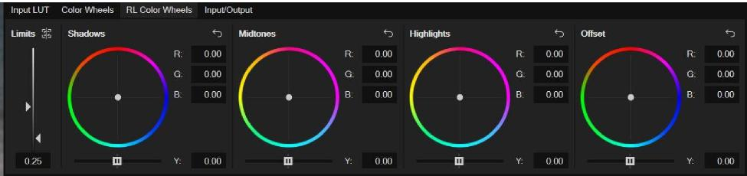
If one of them is not already visible, open the Waveform or RGB Parade video scope. Notice the light blue lines in the scope. These identify the thresholds that limit the color adjustments you make with the RL Color Wheels. Back in the Color Grading panel, use the Show Limits on Scopes button to toggle these indicators off and on.
Adjust the Left Limit slider to change the value of the upper threshold and watch your video scope to see where you’re placing the threshold. Use the Right Limit slider to adjust the lower threshold.
With the thresholds set, make an adjustment to the Shadows color wheel. Notice that the lower threshold setting limits the Shadows color wheel so that changes you make with it affect mainly the material below the low threshold.
Make adjustments to the Highlights color wheel. In the same way, the upper threshold limits these changes to mainly material that rises above the threshold.
Finally, make adjustments to the Midtones color wheel. These adjustments apply mainly to material that exists between the two threshold settings.

VEGAS Pro 19 Introduction to the new features: Initial release and update 1 (build 381)
20

Scene/Edit Detection
When you need to re-edit a video that has already been rendered into a single file, you can use the VEGAS Pro Scene Detection tool to simplify the process. Through the power of AI, Scene Detection automatically detects cuts, fades, and crossfades in your video, then cuts the video into separate timeline clip events or subclips in your Project Media window.
Like the other AI-powered effects in VEGAS Pro, in order for the Scene Detection tool to work properly, you must first install the VEGAS Deep Learning Models. Follow the link to download the Deep Learning Models installer that you received with your VEGAS Pro purchase. You can also download the installer with this link.
To use the Scene Detection tool on a video you’ve already added to your timeline, click the event’s More button and choose Detect Scenes and Split from the menu. The tool analyzes the media in the event and detects scene changes. It then automatically splits the event into separate events, each of which holds a distinct detected scene.
To use the tool at the project media level, click the Project Media tab if necessary to view that window. Here you can either add the detected scenes to your timeline, or create subclips for each individual detected scene.
To detect scenes and add them as separate events to your timeline, right-click the clip in the Project Media list and choose Detect Scenes and Add to Timeline from the context menu. The tool adds the file to your timeline at the current cursor location, detects the separate scenes, and splits the event up into multiple events according to the detected scenes.
If instead you want to create individual subclips in the Project Media bin without adding anything to your timeline, right-click the clip in the Project Media list and choose Detect Scenes and Create Subclips from the context menu. After analysis completes, the tool adds a new subclip to your bin for each individual scene it detects.
You can also detect scenes from your Trimmer window. To do so, right-click your clip in the Project Media window and choose Open in Trimmer from the context menu (or use one of the other methods for adding a clip to your Trimmer window). Click the Trimmer window’s More button and choose Detect Scenes and Add to Timeline from Cursor from the context menu. Again, this results in individual events on the timeline for each detected scene.
Finally, you can add the tool as an effect to a timeline clip event. This can be extremely useful if you want to break a nested timeline or project event on your main timeline into individual events. It can also help when the more automatic methods discussed above don’t yield the results you need and you want to have a bit more control over the process.
VEGAS Pro 19 Introduction to the new features: Initial release and update 1 (build 381)
21

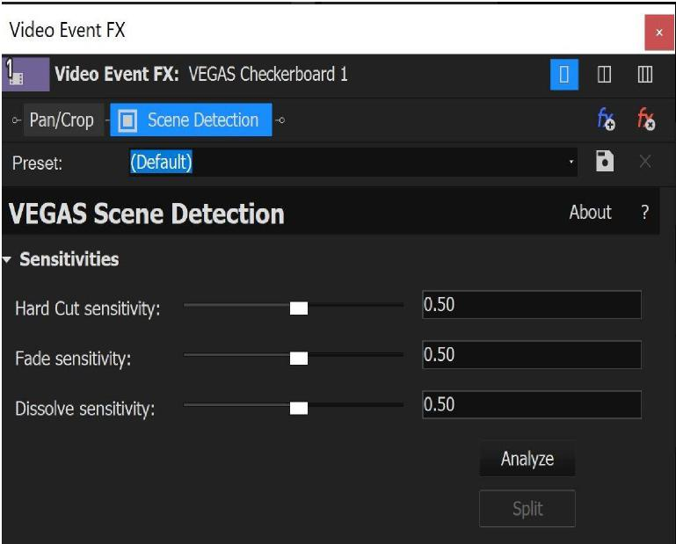
To add this to an event on your timeline, click the Video FX tab to open that window. Select Scene Detection from the list of effects. Drag the Default preset onto the event in your timeline. In the Video Event FX window, click the Analyze button. After the analysis is complete, a keyframe timeline appears and contains keyframes at the location of each cut, fade, or dissolve. You may manually edit these keyframes to fine tune your results.
If you don’t get satisfactory results on the first analysis, Click the Senstivities drop-down arrow to reveal the sensitivity controls. Adjust these controls and re-analyze the clip. Experiment with different sensitivities until you get the result you want.
After you have successfully detected the edits in your video, click the Split button to apply the detected edits to the clip on your timeline.
VEGAS Pro 19 Introduction to the new features: Initial release and update 1 (build 381)
22

Specify White and Black Points
The Specify White Point and Specify Black Point tools enable you to quickly analyze and correct the white and black values of your footage. This helps reduce the amount of time it takes you to color correct and grade your footage.
To use these tools, click the Color Grading button to open the Color Grading Panel. Click the Color Wheels tab if necessary to make the color wheel controls visible.
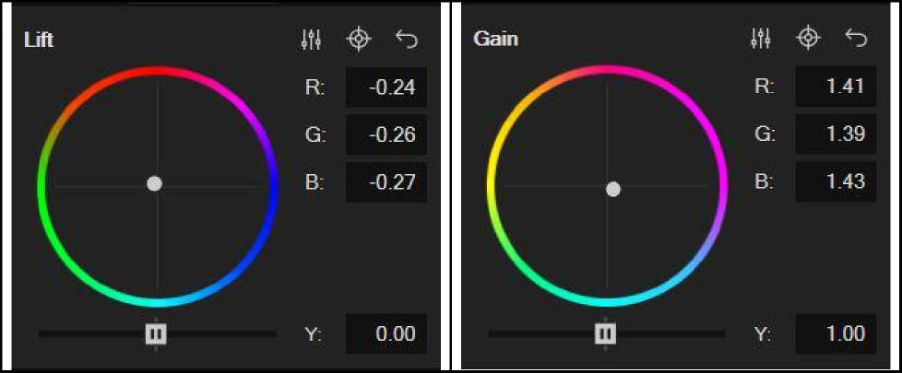
To specify the black point in your video, click the Specify Black Point button for the Lift color wheel.
Point the crosshair mouse icon to a point in your Video Preview window that you want to identify as true black, and click that point. This samples the color and automatically adjusts the Lift color wheel as necessary to make the point true black.
To specify the white point in your video, click the Specify White Point button for the Gain color wheel. Point the crosshair mouse icon to something in your Video Preview window image which should be white, and click that point. This samples the color at that point and automatically adjusts the Gain color wheel as necessary to make the point true white.
After you set the black and white points of your footage, the brightness and contrast levels will be much closer to properly color corrected. This provides a great starting point for you to use to further correct and grade your footage.
VEGAS Pro 19 Introduction to the new features: Initial release and update 1 (build 381)
23

Text to Speech

The feature requires a VEGAS Pro 365 or VEGAS Post 365 subscription.

To be able to use this feature you have to be logged in to the VEGAS Hub. (see below)

The Text to Speech feature in VEGAS Pro enables you to add narration to videos with computer-generated voices through AI technology. With Text to Speech, you can generate spoken narration in several different voices and languages. You can also use it to translate your narrations to various languages with natural-sounding native voices.
To generate narration audio files, choose Tools | Text to Speech. In the Text to Speech dialog box, enter the text you want to turn into audio into the text field. You can either type directly into the field or paste text that you’ve copied from a different source.
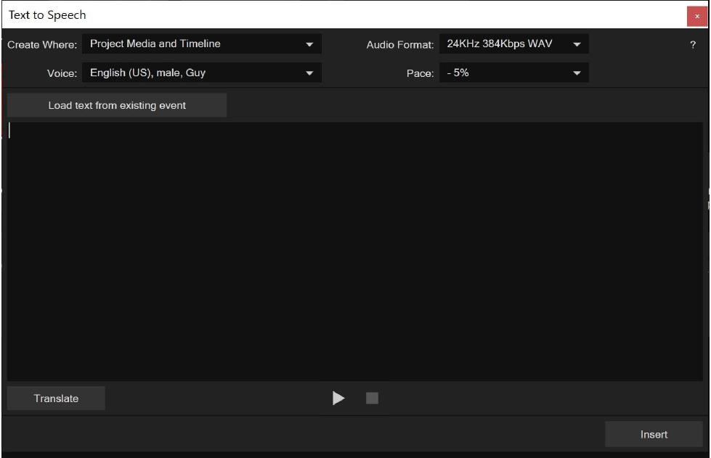
Click the Play button to preview your text. Click the Stop button to stop playback.
To change the voice of the generated text, click the Voice drop-down list and choose the voice you want. To make the voice speak at a different speed, click the Pace drop-down list and choose the speed you want.
Click the Create Where drop-down list to specify whether the resulting audio file will appear in your Project Media and your timeline, or just in your Project Media.
Click the Audio Format drop-down list to select whether you want to create a WAV or MP3 file.
VEGAS Pro 19 Introduction to the new features: Initial release and update 1 (build 381)
24

To translate the text you’ve entered into the text box, click the Translate button. In the Translate Text dialog box, specify the languages that you want to translate from and to. Click OK. This replaces the text in the text field with a translation in the language you specified, and you can apply an appropriate voice to it.
To generate an audio file and add it to your project, click the Insert button. This inserts the audio file into your timeline at the current cursor position, or just in your Project Media bin, depending on which setting you have selected in the Create Where dropdown menu.
If your timeline contains an event that holds an audio file you previously generated with this tool and you want to work with that text again, click the Load Text from Existing Event button. This loads the text back into the field so you can change it or translate it and generate more audio.

VEGAS Pro 19 Introduction to the new features: Initial release and update 1 (build 381)
25

VEGAS Content
Note: Some features of VEGAS Hub are in beta and may not work as expected or be fully implemented. New content and functionality will be continually added to VEGAS Hub as its development continues. Some features, including cloud file storage, require a VEGAS Pro 365 or VEGAS Post 365 subscription.
VEGAS Content gives VEGAS Pro 365 & VEGAS Post 365 subscribers access to nearly a million stock music tracks and video clips. You can use these clips royalty free in any VEGAS Pro project.
To access VEGAS Content, click the VEGAS Hub Login button. Use your MAGIX user credentials to complete the login.
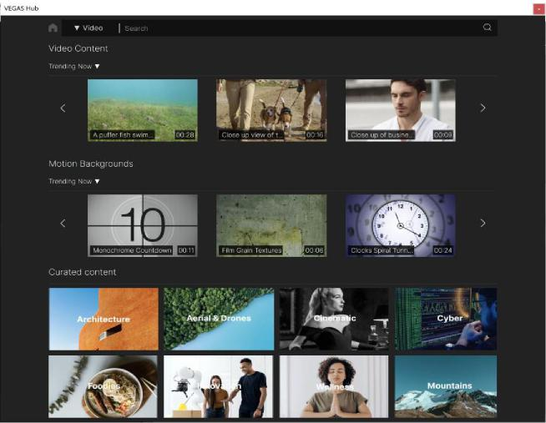
Choose View | Window | VEGAS Hub to open the VEGAS Hub window (See the VEGAS Hub help topic for details). Click the VEGAS Content button to open the content browser pictured above. Type a search word or term into the Search field to search for the content you want. Click the Search button to start the search.
Click the Media Type drop-down list and choose the type of content--audio or video--that you want to preview.
For both video and audio files, set the Duration limits to include only files within a specific length range in your search results. For audio files, set the BPM limits to include only files within a specific tempo range in your search results. Click the Filter Type buttons to further restrict your search results by Content type and Details for audio and video files, Resolution, and Frame Rate for video files, and Categories for audio files.
VEGAS Pro 19 Introduction to the new features: Initial release and update 1 (build 381)
26

To preview an audio file, click its waveform. The file begins to play automatically. To preview a video file, double-click the video thumbnail. Click the Play button.
To download a file, click the Download button. Click the file format and resolution from the list that you want to download. After your download completes, close the Downloads window without making any selections there. To find your downloaded files, open the VEGAS Hub Explorer window (see the VEGAS Hub Explorer help topic for details).
To download more files, click the Back button. To return to the home page of the VEGAS Hub window, click the Home button. The VEGAS Hub home page provides access to your profile information and the VEGAS Creative Software forums, in addition to VEGAS Content. Read the VEGAS Hub section for more information on the VEGAS Hub homepage.
The EULA that you agreed to when installing VEGAS Pro 19 has the details for what you can and cannot do with the stock footage available via VEGAS Content. Please refer to it regarding any copyright disputes that may arise from the use of this content on social media sites.

VEGAS Pro 19 Introduction to the new features: Initial release and update 1 (build 381)
27

VEGAS Hub
Note: Some features of VEGAS Hub are in beta and may not work as expected or be fully implemented. New content and functionality will be continually added to VEGAS Hub as its development continues. Some features, including cloud file storage, require a VEGAS Pro 365 or VEGAS Post 365 subscription.
VEGAS Hub powers all of the online services in the VEGAS family of products, including;
- Secure cloud file storage
- The VEGAS Hub mobile app for Android and iOS which enables you to transfer video and other media directly from your mobile device into your VEGAS Hub cloud storage
- The VEGAS Hub window which provides access to
- VEGAS Content; a stock audio and video content service that provides access to nearly a million high quality audio clips and stock video clips that you can use in your projects royalty free (see the VEGAS Content section for more details)
- The VEGAS Creative Software Forums
- Online help and tutorials
- User profile information
- Other information and features
- AI-powered Text to Speech (see the Text to Speech section for more details)
To use VEGAS Hub, click the VEGAS Hub Login button and log in with your MAGIX account username and password.
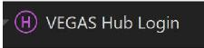
Choose View | Window | VEGAS Hub to open the VEGAS Hub window. The home screen of the VEGAS Hub window contains buttons for the various available features. To access a feature, click the corresponding button.
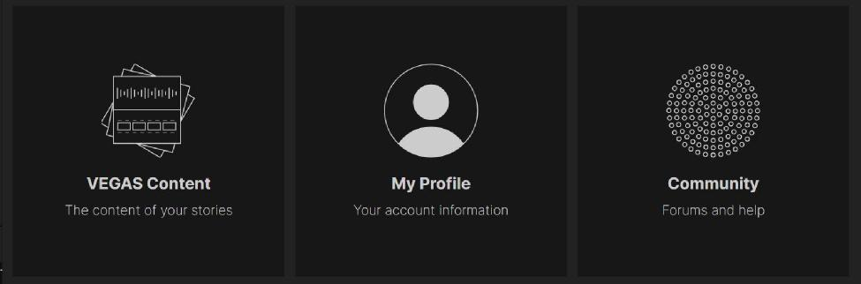
(Read the VEGAS Content section of this document for information on using VEGAS Content.)
VEGAS Pro 19 Introduction to the new features: Initial release and update 1 (build 381)
28

VEGAS Hub Explorer
Note: Some features of VEGAS Hub are in beta and may not work as expected or be fully implemented. New content and functionality will be continually added to VEGAS Hub as its development continues. Some features, including cloud file storage, require a VEGAS Pro 365 or VEGAS Post 365 subscription.
The VEGAS Hub Explorer window enables you to quickly and easily transfer video from your cloud storage (uploaded from your mobile device) or the VEGAS Content library to your VEGAS Pro projects.
To transfer video files from your mobile phone directly into VEGAS Pro via your VEGAS Hub cloud storage, first install the VEGAS Hub mobile app from the Google Play or Apple App Stores onto your mobile device.
Once you have opened the app, login with your MAGIX account information. If you’ve already uploaded files from your device to your VEGAS Hub cloud storage, the app lists them for you. If you have not uploaded any files, a message lets you know that your storage is empty. At the bottom of the app screen, a counter shows how much of your cloud storage space is currently in use.
The amount of cloud storage you have depends on the VEGAS 365 package you have subscribed to. VEGAS Pro 365 comes with 50GB of cloud storage. VEGAS Post 365 comes with 100GB of cloud storage.
Tap the + Upload button to upload a file. You may have to grant the app permissions to access the media files stored on your device before you can choose a file to upload.
Navigate to the location on your device that holds your files and tap the ones you want to upload. When you’ve selected all the files you want to upload, tap the Done link. This uploads the files from your device into your VEGAS Hub cloud storage.
In VEGAS Pro, choose View | Window | Hub Explorer to open the Hub Explorer window. Use your MAGIX credentials to log in if you haven’t already done so.
Click the Mobile Uploads collection in the Collections list. This collection shows all the files you have uploaded to your VEGAS Hub cloud storage and includes the files you just uploaded from your device.

VEGAS Pro 19 Introduction to the new features: Initial release and update 1 (build 381)
29

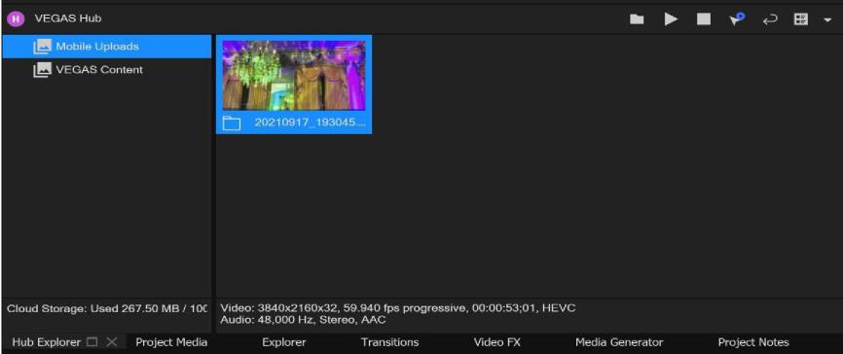
Notice that your new files have a cloud icon. This indicates that the files exist only in your cloud storage and have not been downloaded to your local drive. Right-click a file and choose Sync from the context menu. This downloads the file to your local drive. When the download completes, the file has a checkmark to indicate that it exists both on your cloud storage and on your local drive. Now that you have it locally, you can use any of the normal methods to add it to your VEGAS Pro timeline and work with it.
You can remove a file from your local drive, your cloud storage, or both. To do so, right-click a file and choose Remove from the context menu. In this case, choose VEGAS Hub File from the cascading menu. This removes the file from your VEGAS Hub cloud storage and you now see a folder icon that indicates the file only exits locally. Right-click the file again and choose Sync from the context menu. This uploads the file back to your cloud storage again and once the upload finishes, you see the checkmark icon again.
Additional controls at the top-right of the Hub Explorer window (shown above) enable you to set your file download location, play and stop file preview, enable or disable auto-play, refresh your window, and customize your layout.
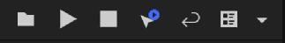
Click the VEGAS Content collection in the Collections list. This collection contains all of the files that you have downloaded from the VEGAS Content database through the VEGAS Hub window (see the VEGAS Content and VEGAS Hub sections for more details). After you download them, these files exist only on your local drive as you can see by the same folder icon discussed above. You can upload any of these files to your cloud storage just as we discussed a moment ago.
With these files on your local drives, you can use all of the normal techniques to add them to your project and edit them.
VEGAS Pro 19 Introduction to the new features: Initial release and update 1 (build 381)
30

VEGAS Upscale
The VEGAS Pro Upscale effect enables you to convert low-resolution video to higher resolutions. For example, you can apply it to HD footage so that you can use it in a 4k project. You can also use it to zoom in on video and preserve apparent resolution. Through the power of AI, VEGAS Upscale produces superior quality upscale and zoom effects.
Like the other AI-powered effects in VEGAS Pro, in order for the Upscale effect to work properly, you must first install the VEGAS Deep Learning Models. Follow the link that you received with your VEGAS Pro purchase to download the Deep Learning Models installer. You can also download the installer with this link.
When you add the VEGAS Upscale effect as a timeline clip event effect, a warning message informs you that you must drag the Upscale effect to the left of Pan/Crop in the plugin chain. You can see the plugin chain in the image below at the top of the Video Event FX window. To change the order, drag the Upscale button to the left and drop it before the Pan/Crop button.
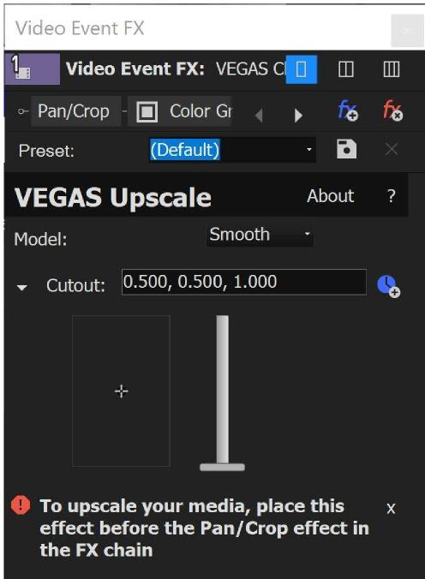
Once you’ve properly ordered your effects chain as discussed above, a Scaling slider appears. When you use the VEGAS Upscale effect as a video event effect, the Upscale plugin automatically upscales the video to your project's resolution as defined in Project Settings, so this slider remains inactive since you don’t need it. But it does tell you the value of the automatic
VEGAS Pro 19 Introduction to the new features: Initial release and update 1 (build 381)
31

setting. If you use the plug-in as a media effect, the slider becomes active and you can adjust it to whatever upscale level you choose.
Drag on the crosshair icon in the Cutout section to pan through the image. Use the arrow keys on your keyboard for fine adjustments.
Adjust the Zoom slider to zoom in and out of your image with the crosshair icon as the target for the zoom midpoint.
To enter exact values for position and zoom, select the values in the Cutout text field and enter the values you want. The first two numbers represent the X and Y coordinates of the crosshair target and the third value represents the current zoom level.
To enable animation of these settings, click the Animate button.

VEGAS Pro 19 Introduction to the new features: Initial release and update 1 (build 381)
32

VEGAS Pro 19 Update 2
Clear Dynamic RAM Preview
During the course of your work in a project, you may have a significant amount of system RAM devoted to the Dynamic RAM Preview function. Whether you’ve purposely loaded frames into your RAM by manually building a dynamic RAM preview section or frames have been loaded in automatically, you may find times when you want to clear all frames from this function.
To do so easily, choose Tools | Clear Dynamic RAM Preview. This flushes all frames from you RAM and frees that memory for other uses.
Preview of selected colors
It sometimes helps to know the exact color value of a point in your video. You can use the color pickers associated with the Set White/Black Point tools in the Color Grading panel to view color values.
To see a color value, click the Color Grading button to open the Color Grading panel. Select an event in your timeline to place the cursor within it so you can view its video in the Video Preview window.
Click the Color Wheels tab if necessary to view the color wheels. Click either the Specify a Black Point or Specify a White Point button. Now, point your mouse to a spot in your Video Preview window.
Back in the Color Grading panel, notice that a color square appears and shows you the colors you point to as you move your mouse. The R, G, and B fields show you the value of the color your mouse currently points to.
Region option when selecting a color
When you use the Specify a Black Point and Specify a White Point buttons in the Color Grading panel, you can specify an area from which to specify an average color. This can sometimes give you more accurate color correction than the value of a single pixel can provide.
To do this, click the Color Grading button to open the Color Grading panel. Select an event in your timeline to place the cursor within it so you can view its video in the Video Preview window.
Click the Color Wheels tab if necessary to view the color wheels. Click either the Specify a Black Point or Specify a White Point button. Now, point your mouse to a spot in your Video Preview window.
If you click at this point, you will sample a single pixel and your automatic color adjustments will be based on the color value of that pixel. Instead of clicking, click and drag through your video to create a sample area rectangle. Once you have the rectangle you want, release your mouse button
VEGAS then samples the entire area you defined and calculates an average of all of the color values
within that area. The tool uses this average to then make the automatic color adjustments.
VEGAS Pro 19 Introduction to the new features: Initial release and update 1 (build 381)
33

Instant access to the Selection Tool from the Normal Edit tool
Sometimes when you’re editing quickly, you need to select all of the events within a certain range of your timeline. The Selection Edit tool provides this functionality. But when you need it for just a quick moment, it slows you down to have to navigate to the toolbar and select the Selection Edit tool, make your selection, and then go back to the toolbar to select the Normal Edit tool again.
In order to quickly move to the Selection Edit tool without interrupting your workflow, while still using the Normal Edit tool, click in your timeline and hold the left mouse button down. While still holding the left mouse button down, click the right mouse button. This switches you to the Selection Edit tool and you can quickly make a selection.
The Selection Edit tool opens in whatever of its three selection states you last left if. To scroll through the three selection states, repeatedly click the right mouse button (while still holding the left button down). This scrolls you through the free-selection, horizontal selection, and vertical selection states.
Once you’ve made your selection, release the left mouse button and you instantly return to the Normal Edit tool.
Color Keys
The Color Grading Panel supports a selection of edits that you can control with the keys on your 10-key number pad. These adjustments enable you to fine tune your color adjustments quickly in multiple ways.
To use these keys, click the Color Grading button to open the Color Grading panel. The keys work on both the traditional Color Wheels and the RL Color Wheels tabs. Click the Color Wheels tab if necessary to bring focus to that section.
Click one of the color wheels that you want to adjust. Notice a gray bar indicates that the wheel now has focus. You can now use your keyboard’s number pad to make adjustments to the settings for this selected wheel. The following table shows the keys and their functions. You can see the effect of many of these adjustments in the Video Preview window, and the Vectorscope is also useful for seeing what’s happening as you press the various keys.
Number pad key | Function
Num 7 | Adds 0.1 to the Red value
Num 4 | Subtracts 0.1 from the Red value
Num 8 | Adds 0.1 to the Green value
Num 5 | Subtracts 0.1 from the Green value
Num 9 | Adds 0.1 to the Blue value
Num 6 | Subtracts 0.1 from the Blue value
Num + | Adds 0.1 to the Y value
Num Enter | Subtracts 0.1 from the Y value
Num 1 | Subtracts 0.1 from the Cyan value

VEGAS Pro 19 Introduction to the new features: Initial release and update 1 (build 381)
34

Num - | Adds 0.1 to the Cyan value
Num 2 | Adds 0.1 to the Magenta value
Num 0 | Subtracts 0.1 from the Magenta value
Num 3 | Adds 0.1 to the Yellow value
Num . | Subtracts 0.1 from the Yellow value
Note: For any of the key combinations above, hold the Ctrl key to change the present value by 0.01
instead of 0.1.
Note 2: The Backspace key resets the currently focused control to its default values
Fine mouse movements for the Color Grading Panel
The controls in the Color Grading Panel—particularly those for the Color Wheels and RL Color Wheels— now enable much finer detail.
In any of the color wheels (or on the color channel sliders), use your Left mouse button to move the control. If you used previous versions of VEGAS Pro, you’ll notice that the changes are much smaller as you drag the control. This enables you to make finer adjustments.
For even finer movement, hold the Ctrl key. Use this technique for extreme accuracy.
If you prefer the larger movements of a previous version of the software, or just want to make large changes quickly, use the Right mouse button to move the control. This matches the speed used by default in previous versions of the software.
Button display independence for Adjustment Tracks
You can now configure your visible button set for Adjustment tracks independently of regular video tracks. As part of this change, Adjustment tracks now show the Track FX button in the track header by default. You can click this button to access the Plug-In Chooser and add the video effects you want to pass through to other tracks. You can also drag video effects directly from the Video FX window onto the Adjustment track header area to add them.
Load text from Titles & Text events into Text to Speech
You can now load the text from any Titles & Text event on your timeline into the Text To Speech tool in order to generate and audio file for that text.
To do this, click the event that holds your Titles & Text generated media to select it. Choose Tools | Text to Speech. In the Text to Speech dialog box, click the Load text from existing event button. This loads the text from the Titles & Text event into the Text to Speech text input field. You can now Preview the audio and make any changes you need, generate and insert and audio file into your timeline, translate the text and make all of the other adjustments available through the text to speech feature.
VEGAS Pro 19 Introduction to the new features: Initial release and update 1 (build 381)
35

5k and 8k render templates in all projects
5k and 8k render templates now appear during the render process for all projects, regardless of the size that has been specified in the Project Video Properties.
To render to 5k or 8k, choose File | Render As. In the Render As dialog box, select MAGIX HEVC/AAC MP4 from the Formats list. Then, select one of the 5k or 8k options from the Templates list. Specify all of your other options as normal, and click the Render button to start rendering.

VEGAS Pro 19 Introduction to the new features: Initial release and update 1 (build 381)
36

